Christmas Newsletter 2017

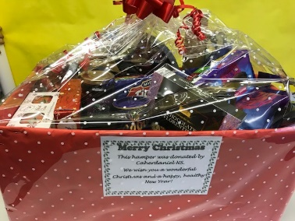
The Christmas spirit came early to Caherdaniel School this year. The boys and girls prepared Christmas shoe boxes for Team Hope. As usual everyone was very generous. Thank you to Niamh O Shea for collecting the shoeboxes.
The senior room made a reverse advent calendar where each class bought in some gifts to create a delicious Christmas hamper for the senior citizens Christmas party.
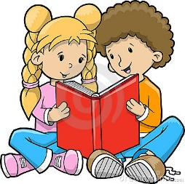
Congratulations to Ciara Foley on winning a prize in the Caherciveen Credit Union Art competition.
Paired reading
This term we ran a very successful paired reading programme. Senior class pupils were paired with pupils in first and second classes twice a week for 20 minutes. The younger pupils read a book of their choice to the older pupils who encouraged and prompted them along the way. The programme promoted a positive school culture and collaborative learning.
Jesse Tree
Father Spillane invited the pupils to the pupils to create a Jesse tree for the church.A jesse tree is used to explain the story of the bible from creation to the birth of Jesus. The tree looks beautiful in the church
New Baby
Congratulations to David and Danielle Hickman on the birth of their baby boy Jacob in December, a baby brother to Eden, Sam and Noah.
Genius hour
The senior room take part in a project called the genius hour where each pupil completes a project on a topic that they are passionate about and share it with their class. We had projects on all kinds of topics from Bitcoin to gymnastics and nail art.
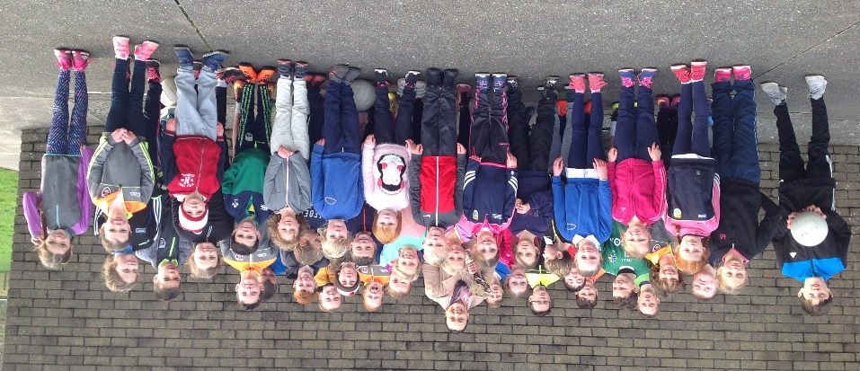
Kerry ladies captain Caroline Kelly brought along her fantastic All Star Award during her days at school with us. She is a great inspiration for both boys and girls.
Junior room news
The junior room have been participating in the Aistear programme .So far they have covered the themes of weather, the opticians and the dentist. Aistear integrates play and learning. First and second class have completed projects on polar animals.

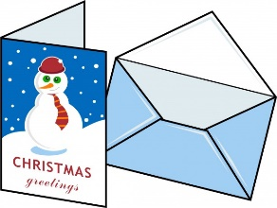
Christmas Cards
The Parents Association organised for the pupils to create Christmas cards and have them printed as Fundraiser. The pupils really enjoyed creating the cards and were really happy with the finished results.

Christmas concert
We hope you enjoyed our Christmas concert, a big thanks to everyone who helped to make it a success. Well done to Mrs O Shea, Trish, Ms Kirby and Bernie for all their handwork preparing the plays. Every single pupil performed fantastically .I would like to say a special word of thanks to Alma O Donoghue and Marianne Van Den Hove for doing the face painting in the morning.
Performing on stage increases a child’s self confidence and self esteem.
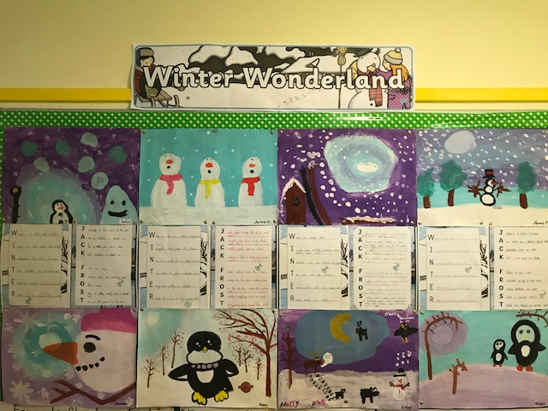
A Christmas night
Santa gets ready to take off
Better go and call Rudolf
Rudolf is here and ready to fly
Mrs Claus comes to say goodbye

Kids all over are going to sleep
Going to bed with a hop, skip and leap
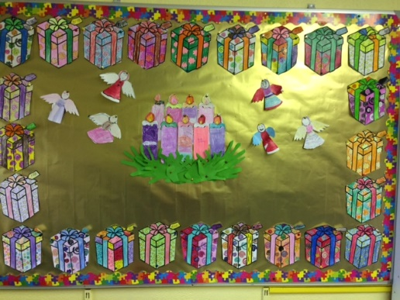
Rudolf’s nose shining so bright
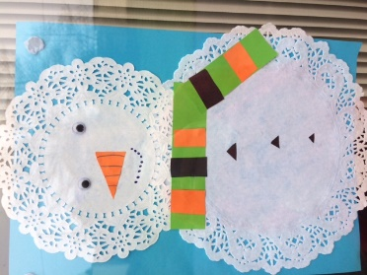
Lighting up the very dark night

Kids start waking up OH NO!
Santa needs to hurry HO HO HO
Everyone wakes up very jolly
They look outside and see snow and holly
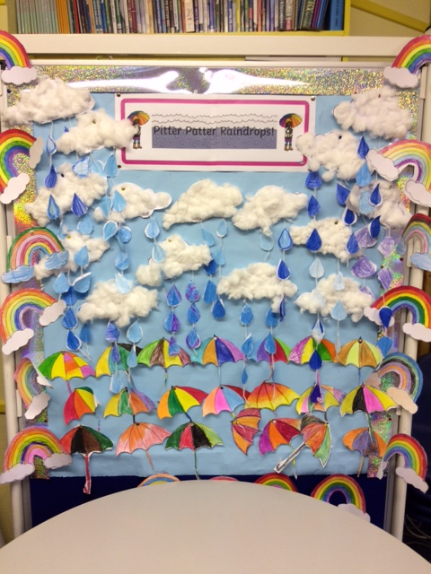
Merry Christmas they say with joy and glee
As they open their presents under the tree

Merry Christmas by Poppy Smith (6th class)

Nollaig Shona agus athbhliain faoi mhaise dhaoibh go leir o gach duine I Scoil Chrochan Naofa

