Summer Newsletter 2018
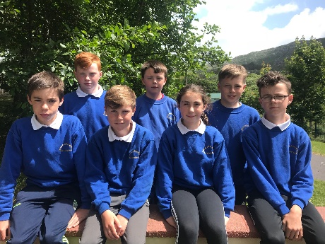
On Tuesday we had our graduation ceremony for 6th class. We say goodbye to Zak Fayen, Aidan O Sullivan, Jamie Gleeson, Luke Donnelly, Brendan Donnelly, Eden Hickman and Poppy Smith. The pupils were presented with special medals to remember their time in Caherdaniel National School. We wish them every success in secondary school.
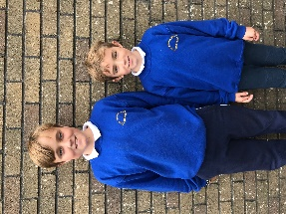
We welcomed two new pupils to the school this term-Oscar (5th class) and Teddy (1st class).The boys and their parents Bones and Ruth O Connor moved from Perth, Australia back to Kerry.
Our four new juniors came in to school for an afternoon, they are all very keen to start school-Kian Salter, Aisling Breen, Lauren Gleeson and Etain Pickard will join us in September. We will have 38 enrolled next school year.
Active Week
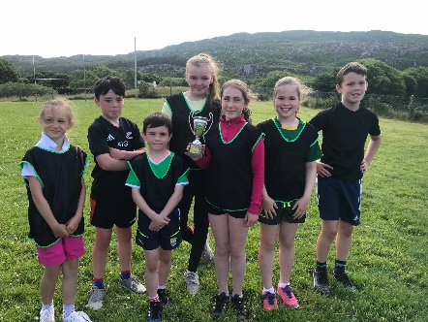
We held Active Week in school on the week of the 11th of June to the 15th June. Sports Day was on the Monday. The final of the soccer league was the first event. The two teams competing were Poppy’s team versus Zak’s team. It was a very close game, the teams were level going into the final minute 2-2, however Conall Cournane scored a goal in the dying moments of the game achieving victory for Poppy’s team .The School Cup will reside in Farraniaragh for the next year. Zak Fayen won the golden boot for the third time .After that we had the usual fun and games –sack races, egg and spoon, musical chairs etc. As a treat for the pupils we ordered an ice-cream van to come to the school. We have got great praise for our pupils in the last few weeks-the swimming coaches remarked on how well behaved and attentive they were in the water, the ice-cream man remarked how polite and mannerly they were and the instructors on the school tour informed us that they were the best behaved pupils that they had had at the camp this year.
On Tuesday we walked the Kerry Way to Coad and back, the day was beautiful and the views were splendid. On
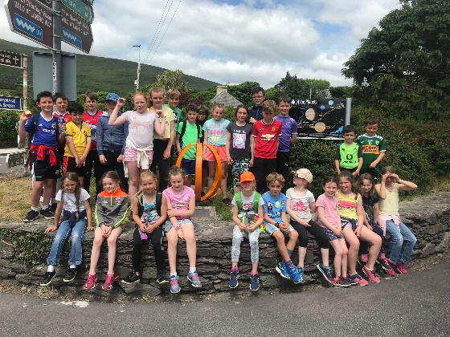
Friday we went to Active Kingdom for our school tour, we had brilliant instructors who really engaged with the pupils.
Swim Week
We had fantastic sunny weather for our swim lessons on the beach. We all got a great colour from the few days. Huge thank you to the parents who cooked the lovely food on the last day-it was a great treat.
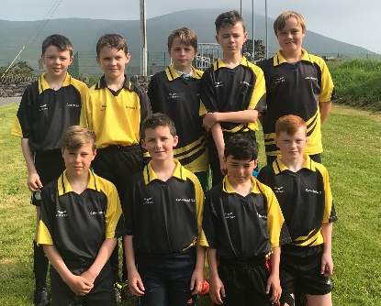
Sports
Our senior room took part in a soccer blitz and a basketball blitz in Caherciveen and although they did not win they enjoyed taking part.
Music composition
We were very lucky to be selected by Kerry County Council to have a composer in residence for 6 weeks. The composer Ian Wilson helped the pupils in second to sixth class compose a piece of music based on their local environment. The pupils performed this Tuesday at the graduation.
We are Writers
Jacinta O Shea and I completed a yearlong course in Professional leadership for Principals and Deputy Principals this year. As part of our project we had to undertake a new initiative in the school. We decided to implement a peer tutoring programme where senior pupils were paired with junior pupils in reading, writing and technology. It worked really well, we then decided to create our We are Writers book. The book is and will be a lovely snapshot in time of a child’s innocence, imagination and wonder at the world.
Ice-cream Party
On Wednesday of this week we held a HB ice-cream party in aid of Down Syndrome Ireland. The pupils raised €120 for this very worthy cause.
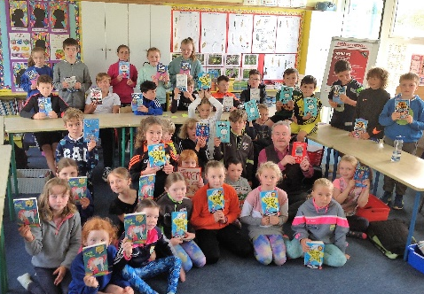
Book Gifts
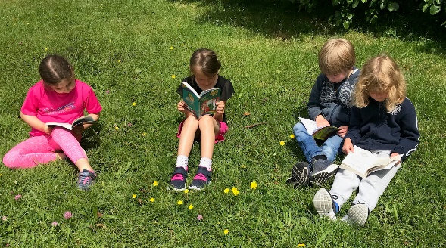
Colman Quirke, our nearest bookshop in Caherciveen, is celebrating 40 years in business this year. To mark this occasion he is presenting every child in the 11 local south Kerry schools with a brand new book. Colman visited today and presented every child with a book. It is so vital to enthuse and encourage a love of reading amongst our pupils. Some of our younger pupils took the opportunity to start their new books at break time today!
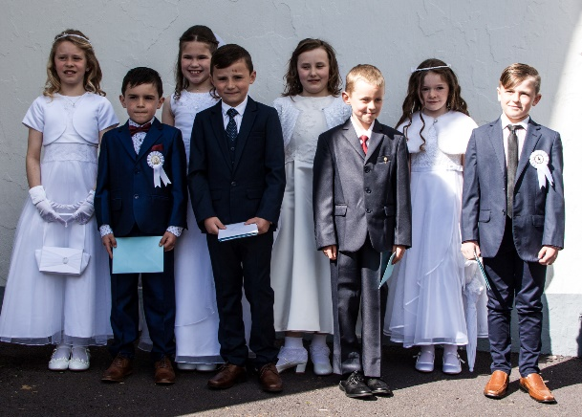
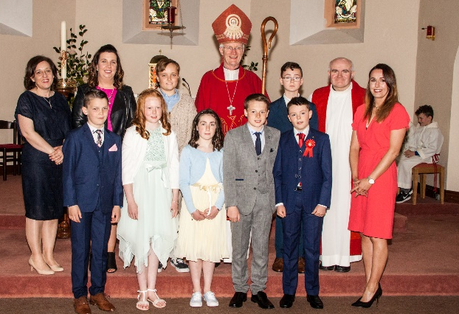
Confirmation & Communion
Congratulations to all our pupils who received their confirmation and First Communion this year. A big thank you to the class teachers-Ms O Shea and Ms Kirby and the SNAs-Trish and Bernie for all their hard work in preparing for the ceremonies.

Summer Holidays
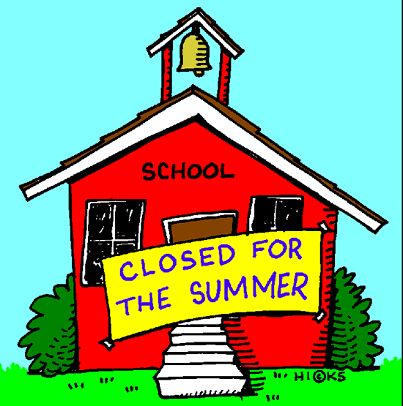
School reopens on Thursday 30th of August. We also say goodbye enviously this year to our shared Resource teacher Ms Sarah Dillon who is taking a year out to go travelling the world. We wish her safe travels.
We are collecting Lee Strand tokens for next year so please remember to save them during the summer and thanks for all the tokens sent in.
Thank you all for your support during the year and we hope everyone has a safe and enjoyable summer.
Yours sincerely
Maria Maunsell
Principal

