Halloween Newsletter 2018
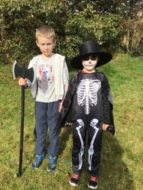
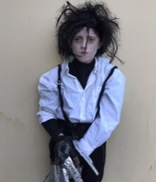
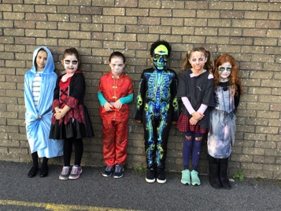
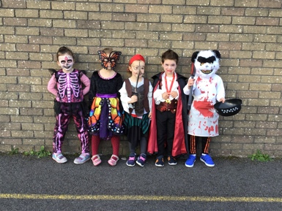
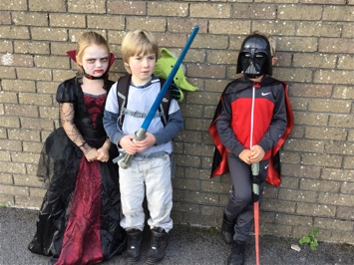
Greetings from a spooktacular Caherdaniel NS.We have just come back from our Ghostly trail through the village. As usual the costumes were fantastic especially the homemade ones. We had our first ghost fridge this year. We raised €72.50 for the Indonesian Earthquake fund which we will donate to Concern.
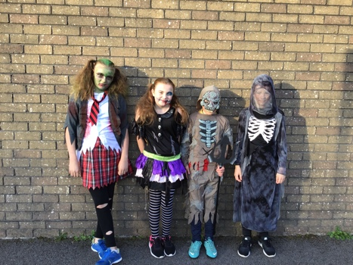
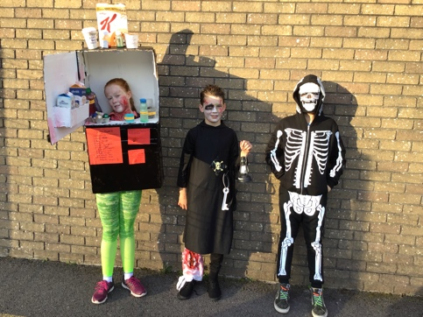
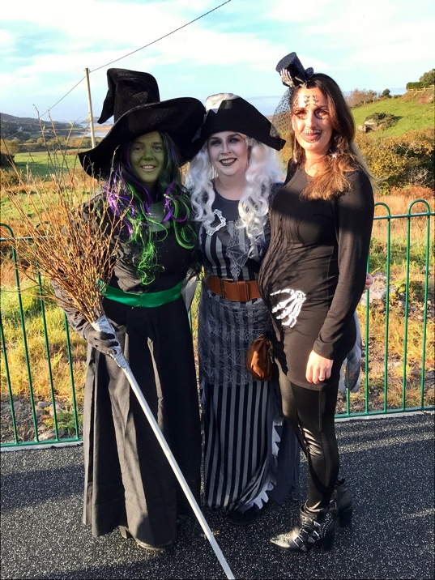
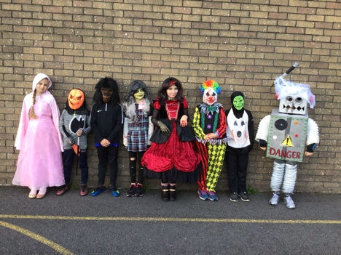

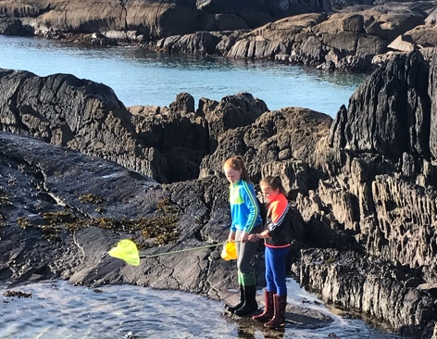
The senior room went on a sea safari on Derrynane Beach on Wednesday, they discovered lots of interesting facts about our local seashore. They were blessed with a beautiful day. Thanks to sea synergy for organising the safari. Last week well known round the world sailor and past pupil Damien Fox hall visited the senior room to tell the pupils about all his hair raising adventures and what life at sea is really like. Damien showed the pupils where he used to sit when he was in Caherdaniel school and then very kindly announced that there would be no homework that night! Thanks to sea synergy for organising the visit.

Congratulations to Ciara Foley in fifth class who represented the school at a swimming gala in UL in Limerick.Ciara did really well at the gala and achieved some great swimming times.
The pupils have just completed 5 golf lessons with Adrian. Golf is a great hobby as it can be a lifetime sport.

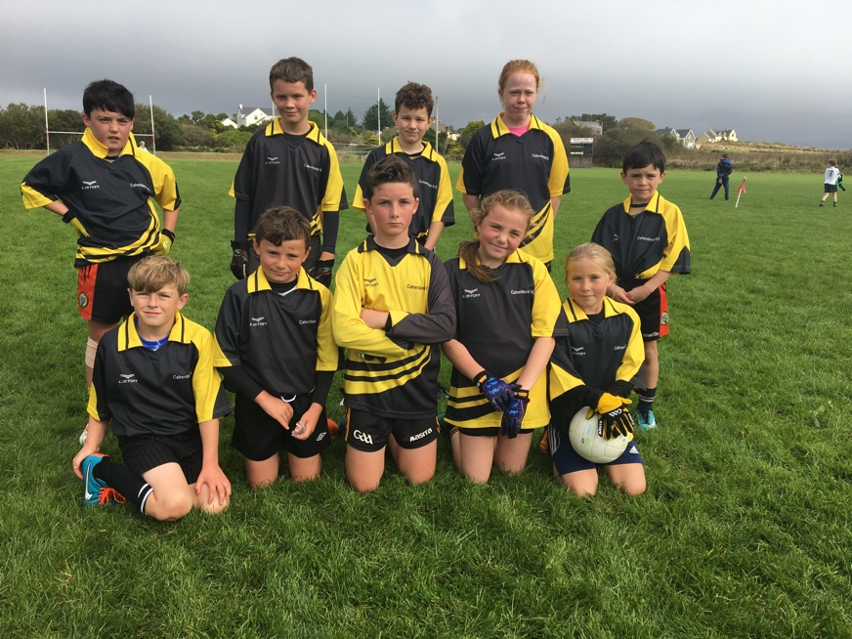
We participated in Cumann na mbunscoil this year, although we did not win we had a great day out in Ballinskelligs.Foilmore School went through this year and we wish them all the best for the rest of the competition. Third and fourth class will be participating in an indoor school soccer blitz in the Aura in Killarney on Tuesday November 20th .We have to be there for 10am so if you are free to drive let the class teacher know.
Our book fair starts on Wednesday November 14th.Parent Teacher meetings are scheduled for Thursday 22nd November.
Under Clar funding much needed safety works to the value of €50,000 are to be put in place outside the school. The school has to pay for 10% of the total value of the works. The government are not paying any school grants until January 2019.Money is scarce this year. We will be having a Christmas Carol service and mulled wine/hot chocolate and mince pie reception followed by a monster raffle on Thursday 13th of December at 7pm.We will have more information after Halloween.

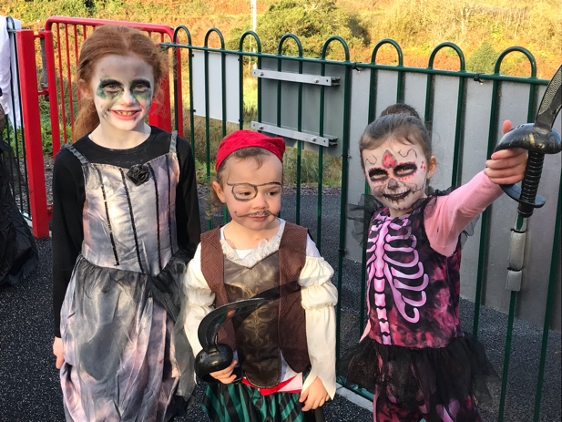
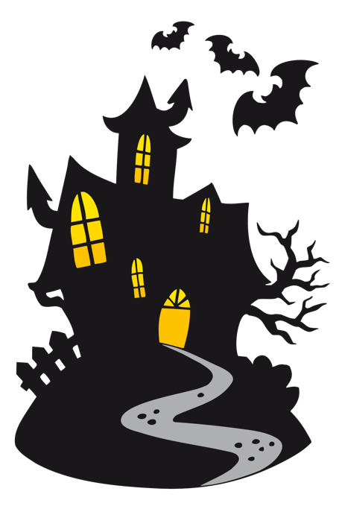
Hope everyone has an enjoyable break; school will reopen on Monday 5th of November.

